**How to resolve in Visual Studio strcpy errors?**

1. If the Solution Explorer view is not active select View->Solution Explorer:

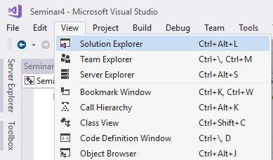

2. Right click on the project and select Properties:

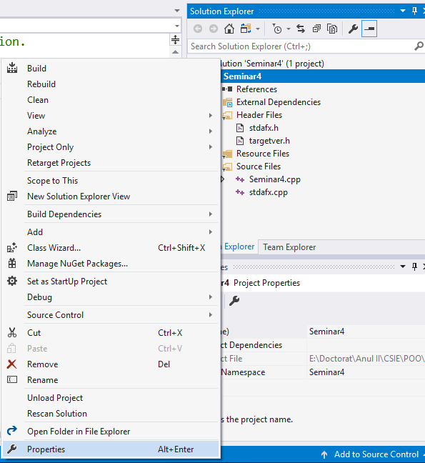

3. Select under Configuration Properties -> C/C++ -> Preprocessor:

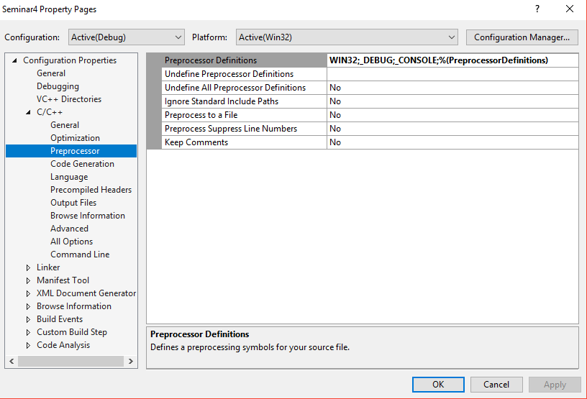

4. Edit the Preprocessor Definitions:

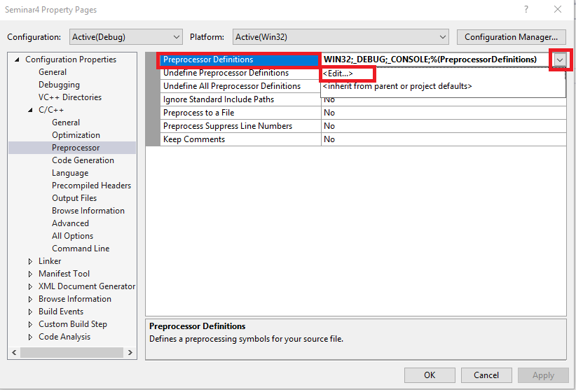

4. Add: _CRT_SECURE_NO_WARNINGS and select OK.

